How to identify and run code in real ios device?

Step1 :

Install 🡪 brew install carthage

Step2:

Install 🡪 appium driver list

Make sure the xcuitest 🡪 [xcuitest@5.8.2](mailto:xcuitest@5.8.2) shows installed

If not installed use the below command to install,

Step3:

If your xcuittest is installed then run the command to identify the webdriver agent using below command (usually it take up to 2-3 minutes to give the result)

find . -name "appium-webdriveragent"

it should populate a result something like a path as below,

./.appium/node_modules/appium-xcuitest-driver/node_modules/appium-webdriveragent

Step3:

Navigate to the above path in the finder and click on the “WebDriverAgent.xcodeproj” in the path

It will open the xcode project

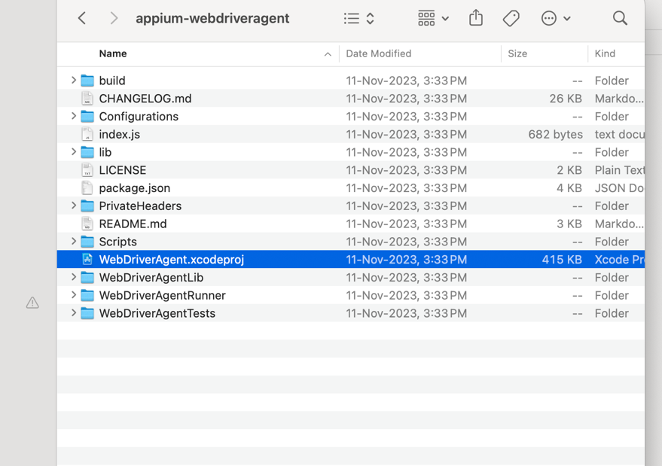

Step4:

Connect your real device via cable

The real device will ask to Trust the computer 🡪 just provide yes

It takes some time to get the webdriver agent running/ready for the real device

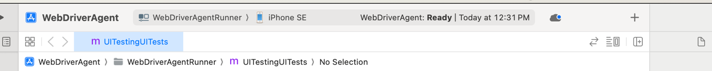

Step5:

Make sure you are logged in to developer account by navigating to

Xcode🡪 settings🡪 Account

Its free profile and can be used for simple testing

Step6:

Then we need to identify the provisioning profile

Click on Webdriver agent from the xcode

Then on the tab “signing and capabilities” tab

Now under the dropdown “Team” select your developer account (which should be listed if you have created one)

Now after this it will provide error in the try to change com.facebook.WebDriverAgentRunner to com.facebook119.WebDriverAgentRunner or try different number after facebook as it shouldbe unique

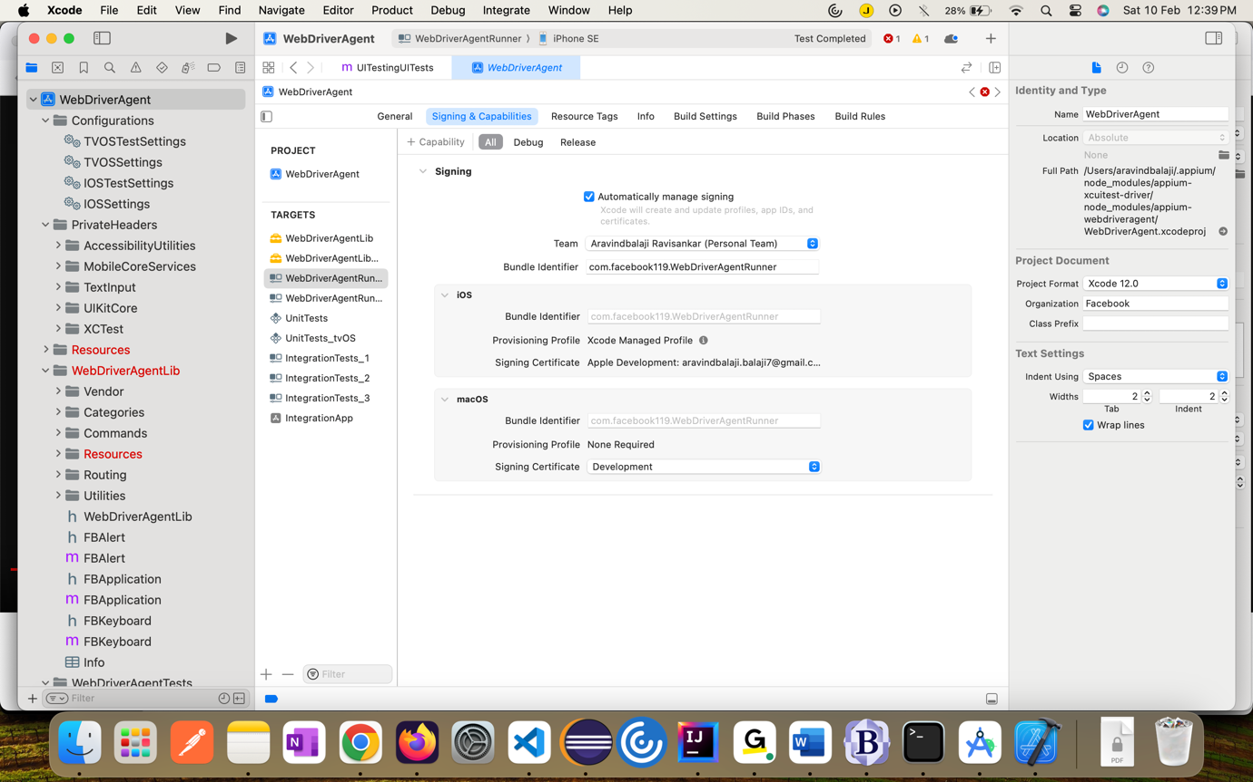

Step7:

How to identify the udid of the device

Xcode🡪 window🡪 devices and simulator 🡪 identifier

